**Modification on Conventional Visible and Infrared Image Fusion Methods for Real-time Applications**

**Submitted**

**By**

**Netla Shanmuka Harshavardhan Reddy –BU21EECE0100186**

**Battula Thanuja –BU21EECE0100295**

**Siddavatam Mohammad Khwaja Moinuddin –BU21EECE0100381**

**Under the Guidance of**

**Dr Jeevan K M, Assistant Professor**

**(Duration: 26/11/2024 to 28 /03/2025)**



**Department of Electrical, Electronics and Communication Engineering**

**GITAM School of Technology**

**GITAM**

**(DEEMED TO BE UNIVERSITY)**

**(Estd. u/s 3 of the UGC act 1956)**

**NH 207, Nagadenehalli, Doddaballapur taluk, Bengaluru-561203 Karnataka, INDIA.**

**DECLARATION**

**We declare that the project work contained in this report is original and it has been done by me under the guidance of my project guide.**

**Name:**

**Dr Jeevan K M**

**Date:**

**19-03-2025 Signature of the Student**

**N. Shanmuka Harsha**

**B. Thanuja**

**S. MD. Khwaja Moinuddin**

**Department of Electrical, Electronics and Communication Engineering GITAM School of Technology, Bengaluru-561203**

****

**CERTIFICATE**

**This is to certify that (Netla Shanmuka Harshavardhan Reddy BU21EECE0100186), (Battula Thanuja –BU21EECE0100295), and (Siddavatam Mohammad Khwaja Moinuddin – BU21EECE0100381) has satisfactorily completed Mini Project Entitled in partial fulfillment of the requirements as prescribed by University for VIIIth semester, Bachelor of Technology in “Electrical, Electronics and Communication Engineering” and submitted this report during the academic year 2024-2025.**

**[Signature of the Guide] [Signature of HOD]**

**Dr. Jeevan. K.M Dr. Prithvi Sekhar Pagala**

**Table of contents**

[**Chapter 1: Introduction 1**](#_heading=h.gjdgxs)

[1.1 Overview of the problem statement 1](#_heading=h.30j0zll)

[1.2 Objectives and goals 1](#_heading=h.1fob9te)

[**Chapter 2 : Literature Review 2**](#_heading=h.3znysh7)

[**Chapter 3 : Strategic Analysis and Problem Definition 3**](#_heading=h.2et92p0)

[3.1 SWOT Analysis 3](#_heading=h.tyjcwt)

[3.2 Project Plan - GANTT Chart 3](#_heading=h.1t3h5sf)

[3.3 Refinement of problem statement 3](#_heading=h.2s8eyo1)

[**Chapter 4 : Methodology 4**](#_heading=h.17dp8vu)

[4.1 Description of the approach 4](#_heading=h.3rdcrjn)

[4.2 Tools and techniques utilized 4](#_heading=h.26in1rg)

[4.3 Design considerations 4](#_heading=h.lnxbz9)

[**Chapter 5 : Implementation 5**](#_heading=h.1ksv4uv)

[5.1 Description of how the project was executed 5](#_heading=h.44sinio)

[5.2 Challenges faced and solutions implemented 5](#_heading=h.2jxsxqh)

[**Chapter 6:Results 6**](#_heading=h.z337ya)

[6.1 outcomes 6](#_heading=h.3j2qqm3)

[6.2 Interpretation of results 6](#_heading=h.1y810tw)

[6.3 Comparison with existing literature or technologies 6](#_heading=h.2xcytpi)

[**Chapter 7: Conclusion 7**](#_heading=h.1ci93xb)

[**Chapter 8 : Future Work 8**](#_heading=h.2bn6wsx)

[**References 9**](#_heading=h.1pxezwc)

# **Chapter 1: Introduction**

## Overview of the problem statement

## The project tackles the problem of improving "visible and infrared image fusion" for real-time applications, in which data from both imaging modalities is essential. While visible images give rich details in color, texture, and shape, infrared images capture thermal radiation, so providing crucial data in low-light or night vision situations and temperature detection. Especially in fields like "surveillance, medical imaging, and remote sensing," the combination of these images greatly enhances decision-making by offering a whole view of a scene. Many current deep learning (DL) techniques for image fusion depend on past knowledge and effort to extend over various environmental and lighting situations. For real-time applications, this reduces their efficiency particularly in cases of limited hardware resources. Though simpler and more compatible with current hardware, conventional fusion techniques sometimes lack the efficiency and image quality needed for real-time processing.

## The project intends to modify and improve conventional fusion techniques in order to raise the quality of fused images and increase their suitability for real-time uses. Maintaining simplicity and efficiency while guaranteeing compatibility with existing hardware is the main emphasis; current deep-learning methods are limited in this regard.

## Objectives and goals

* Objectives:

## To develop and optimize algorithms that improve the fusion of visible and infrared images, ensuring the preservation of critical information from both modalities in real-time applications.

## To enhance the computational efficiency of conventional image fusion methods, enabling their deployment on resource-constrained devices without compromising performance.To integrate the modified image fusion techniques seamlessly with existing real-time systems, facilitating their adoption in applications like surveillance, medical imaging, and remote sensing.

## Goals:

## **Main Goals** Multi-Resolution DetailsRemote SensingEnhanced Visualization and Analysis

## **Additional Goals:**Real-time ProcessingAccurate

# **Chapter 2: Literature Review**

## Key Publications

|  |  |  |  |  |
| --- | --- | --- | --- | --- |
| S.NO | Title | Author | Published In | Abstract |
| 1 | A Color-Focused Visible and Infrared Image Fusion Framework for Aiding Human Perception | Nithin Eswarappa, Shefali Waldekar, Jeevan K.M, Bikram Kumar Vivek and Koshy George | 2024 IEEE International Conference on Electronics, Computing and Communication Technologies (CONNECT),  Date of Conference: 12-14 July 2024,  Date Added to IEEE Xplore: 20 September 2024 | Image fusion methods are required when images from the same or different sensors are available. In several applications, photographs from a color camera are often fused with thermal infrared (medium-wave or long-wave) images. This paper focuses on those applications (typically security and  surveillance) where the fused images are used by a human operator who will, in turn, make critical decisions. This paper presents two frameworks for fusing color and infrared images, one in the red-green-blue (RGB) color space and the other in the lightness-chroma-hue (LCH) color space. We compare qualitatively and quantitatively the performance of five existing fusion methods that work best in this scenario. The study is carried out across two datasets. Quantitatively, four existing metrics are used to analyze the performance. In addition, this paper proposes a performance metric that appeals to human perception and measures how well color, edge, and contrast information are transferred to the fused image. |
| 2 | Infrared and visible image fusion based on domain transform filtering and sparse representation. | Xilai Li, Haishu Tan, Fuqiang Zhou, Gao Wang,Xiaosong Li | June 2023, Infrared Physics & Technology, Volume 131, 104701 | This paper presents a new method for combining infrared and visible images to provide clearer and more detailed images of complex scenes. The process involves breaking the images into simpler base layers and detailed layers. The detailed layers are merged using a technique that enhances important features. A special filter (DTF) is used to combine the base layers while keeping key structures and edges intact. This approach helps retain important details from both images. Tests show that the method produces better results than other existing methods, both visually and in terms of measurable quality. |

## Key Resources

|  |  |  |  |  |
| --- | --- | --- | --- | --- |
| S.NO | Title | Author | Published In | Abstract |
| 1 | Image Fusion technique using Multi-resolution singular Value decomposition | V.P.S. Naidu | 5, September 2011, defence Science Journal, Vol. 61, pp. 479-484 | A novel image fusion technique based on multi-resolution singular value decomposition (MSVD) has been presented and evaluated. The performance of this algorithm is compared with that of a well-known image fusion technique using wavelets. It is observed that image fusion by MSVD performs almost similarly to that of wavelets. It is computationally very simple, and it could be well suited for real-time applications. Moreover, MSVD does not have a fixed set of basis vectors like FFT, DCT, wavelet, etc., and its basis vectors depend on the data set. |

# **Chapter 3: Strategic Analysis and Problem Definition**

## 3.1 SWOT Analysis

* Strengths

## Valuable Information from Infrared Imaging

## Enhanced Decision-Making

## Efficiency of Conventional Methods

* Weaknesses

## Dependency on Conventional Methods

## Hardware Constraints

## Generalization Challenges

* Opportunities

## Adaptation to Emerging Technologies

## Market for Resource-Constrained Environments

## Government and Defense Contracts

## Healthcare and Medical Imaging

* Threats

## Competition from Advanced Techniques

## Security and Privacy Concerns

## 3.2 Project Plan - GANTT Chart

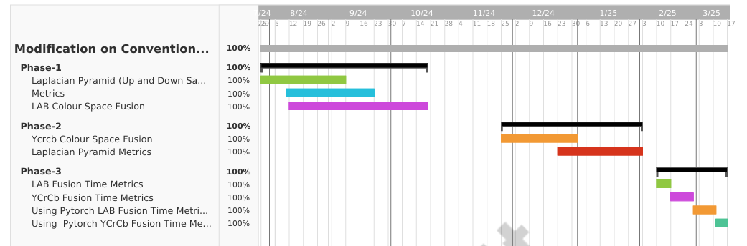

## 3.3 Refinement of problem statement

## To improve the quality, efficiency, and real-time applicability of fused images by introducing unique modifications to conventional visible and infrared image fusion techniques. The project's goal is to develop algorithms that efficiently integrate visible and infrared data, making them suitable for diverse real-world applications like remote sensing, medical imaging, and surveillance as well as resource-constrained settings.

# **Chapter 4: Methodology**

## 4.1 Description of the approach

## In this project, we describe the approach used to adapt conventional visible and infrared image fusion techniques to real-time application needs. Our strategy focuses on improving current fusion algorithms to increase their efficiency, robustness, and performance in a range of real-world situations. **Multi-Resolution Analysis:**

## We effectively fuse fine and coarse details by breaking down images into various resolution levels using wavelet transforms. Important features are maintained and emphasized in the finished fused image through to this hierarchical approach.

## **Real-Time Optimization:**

## In order to make algorithms suitable for real-time processing, we optimize them for speed and low latency, giving priority to computational efficiency. This covers hardware acceleration methods and parallel processing.

## 4.2 Tools and techniques utilized

## **Software Tools:**

## We utilize programming environments such as Python with libraries like OpenCV and NumPy for image processing and fusion tasks.

## **Hardware Platforms:**

## Our implementations are tested on resource-constrained devices, including Raspberry Pi and NVIDIA Jetson, to ensure the algorithms are efficient and scalable.

## **Fusion Algorithms:**

## Wavelet Transform: Used for multi-resolution decomposition, enabling the fusion of images at different levels of detail.

## **Laplacian Pyramid:**

## Another multi-resolution technique that helps in blending images smoothly and preserving edges.

## 4.3 Design considerations

## **Scalability:**

## To effectively manage large datasets and high-resolution images, we take into account the scalability of our methodology. This entails maximizing processing power and memory utilization.

## **Real-Time Processing:**

## We create our fusion algorithms with low latency and high efficiency in mind to satisfy the demands of real-time applications. Using the parallel processing power of contemporary CPUs and GPUs is part of this.

## **Chapter 5: Implementation**

## 5.1 Description of how the project was executed

## **Requirements Analysis and Planning:**

## We began by clearly defining the objectives of the project, focusing on enhancing existing image fusion techniques to work efficiently in real-time and resource-constrained settings.

## A thorough review of current image fusion methods, particularly those used in visible and infrared imaging, was conducted to identify strengths, weaknesses, and potential areas for improvement.

## The primary objectives include **preserving critical information** from both image modalities, **improving computational efficiency** for real-time performance, and **integrating** the fusion method with existing systems.

## The analysis targets key performance indicators such as **processing speed, accuracy of fused images**, and **preservation of essential visual and thermal details**. Metrics like **PSNR, SSIM,** and **entropy** are defined as benchmarks.

## **Algorithm Development and Adaptation:**

## Based on the literature review, we selected promising conventional image fusion algorithms such as wavelet transforms, and Laplacian pyramids.

## Adapting the Laplacian Pyramid (LP) Method: The algorithm was modified to handle multi-resolution details, ensuring the fusion retains high-frequency (edge) and low-frequency (intensity) information from both input images. This involved optimizing the code for parallel processing and reducing the computational complexity where possible.

## Real-Time Optimization: The algorithm was further adapted to reduce computational overhead, enabling deployment on resource-constrained devices like NVIDIA Jetson Nano. Techniques like CUDA acceleration and pyramid downsampling were integrated to boost speed without sacrificing quality.

## The fused images were evaluated using metrics like Structural Similarity Index (SSIM), Peak Signal-to-Noise Ratio (PSNR), and visual inspection to assess the quality and effectiveness of the fusion.

## 5.2 Challenges faced and solutions implemented

## The project faced several significant challenges, from ensuring computational efficiency and real-time processing to maintaining robustness and adapting to new technologies. Through a combination of algorithm optimization, adaptive techniques, and efficient data handling, these challenges were effectively addressed. The solutions implemented not only enhanced the performance and reliability of the image fusion methods but also ensured their applicability across a wide range of real-time applications and resource-constrained environments.

# **Chapter 6: Results**

## 6.1 outcomes

## **Fusion Time Metrics YCrCb Using Pytorch (GPU)**

## Visible Images

## 

## Infrared Images

## 

## Fused Images

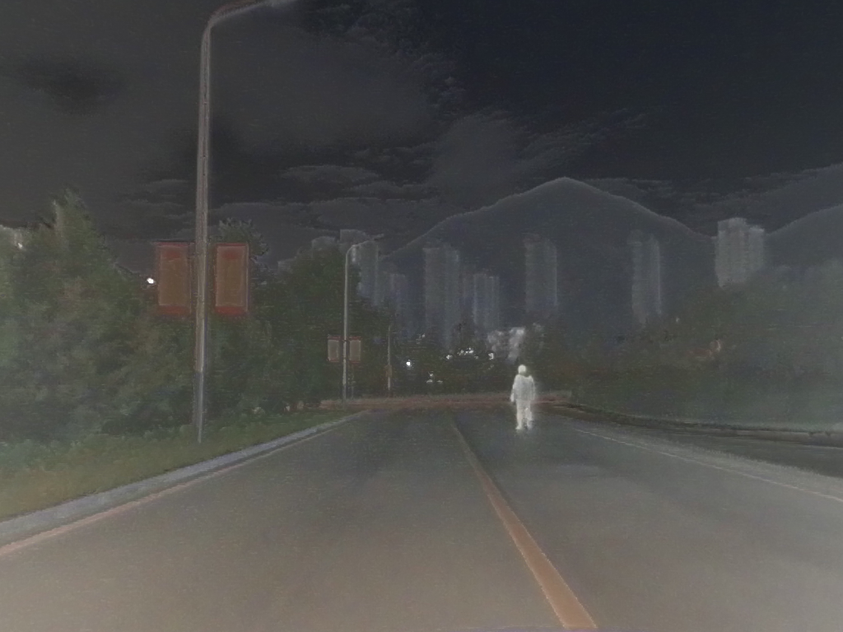 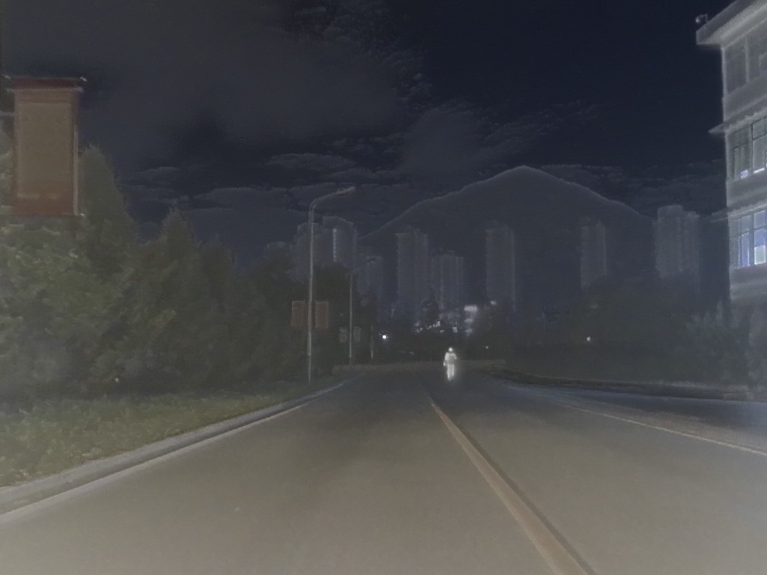

**YCrCb Fusion Time Metrics (CPU)**

Visible Images

## 

## Infrared Images

## 

## Fused Images

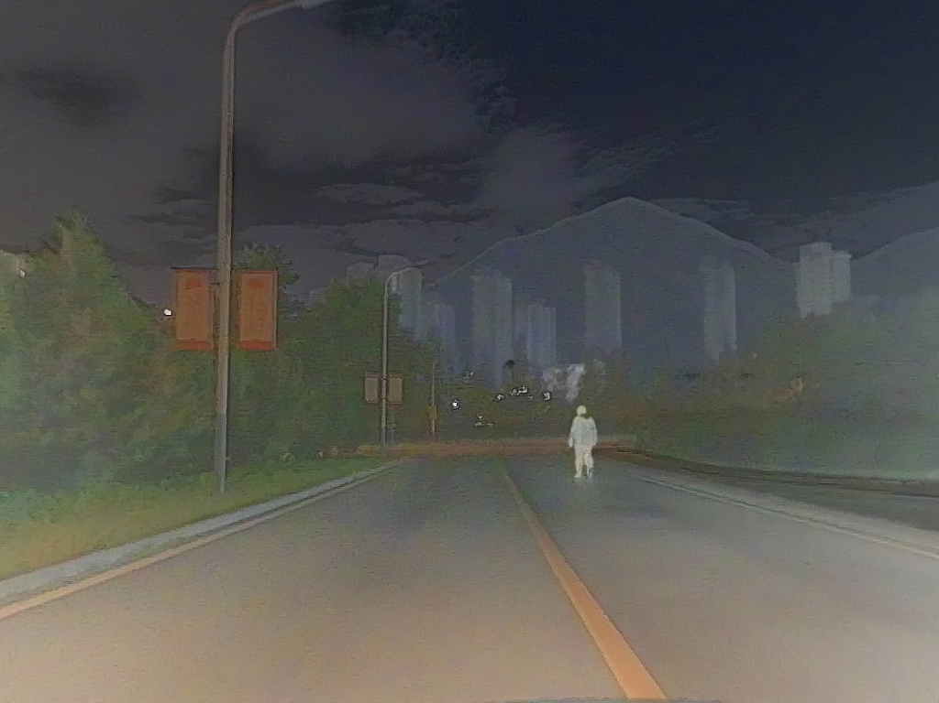 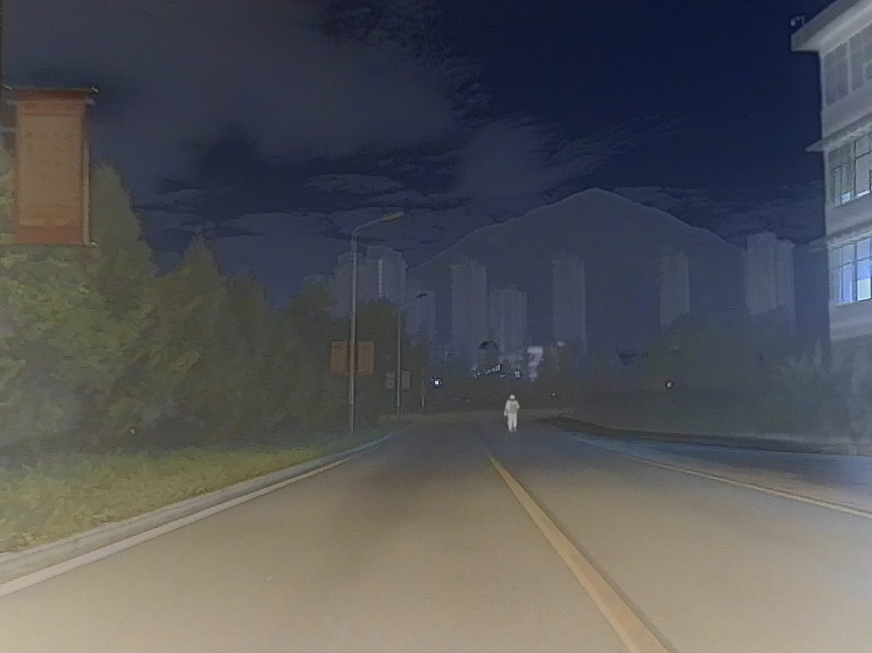

## upload_post_object_v2_673480586

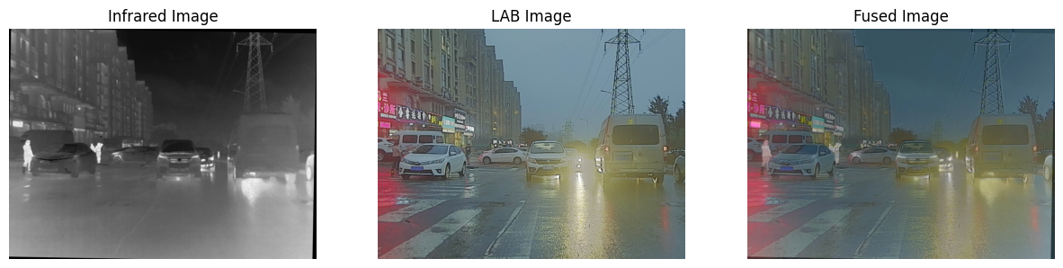

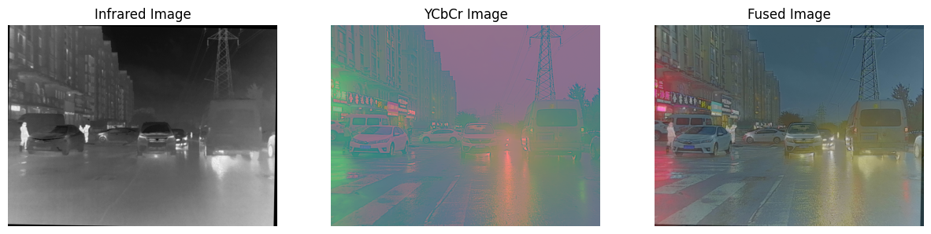

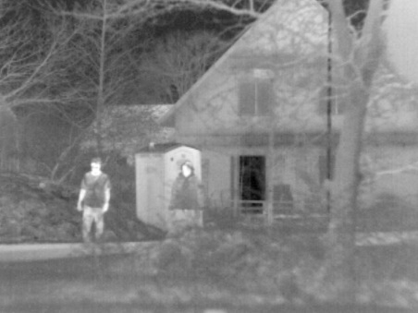 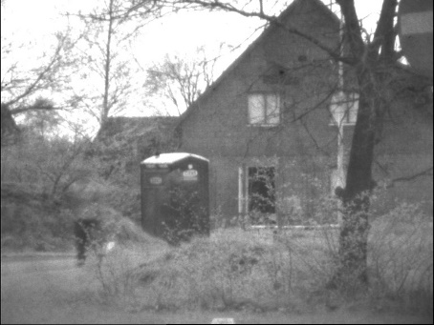 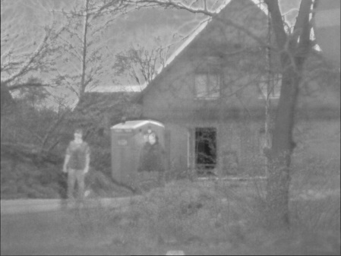

## 6.2 Interpretation of results

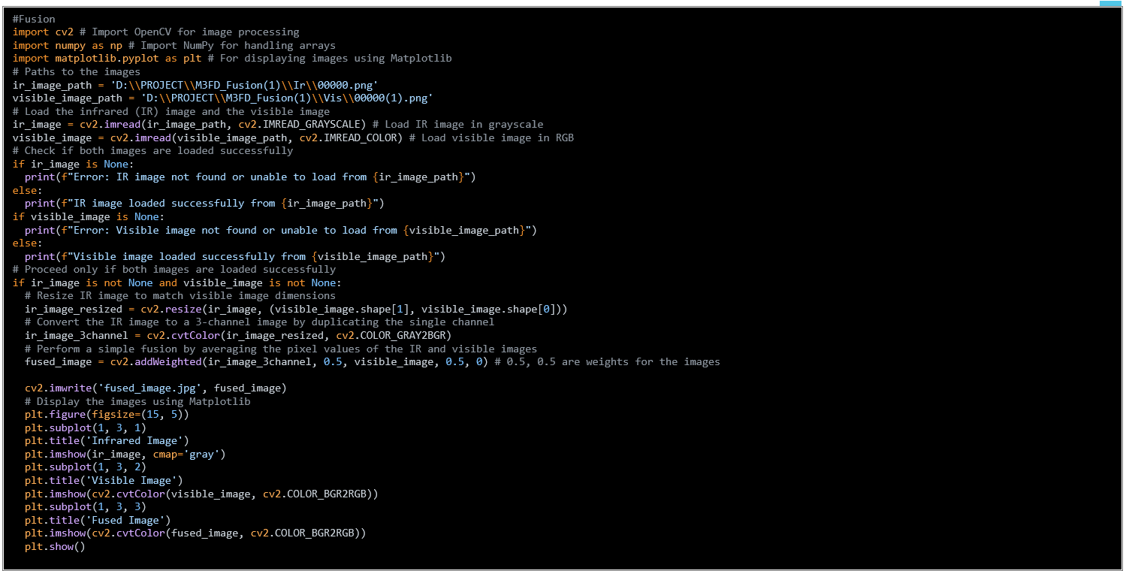

## 

* import cv2
* import numpy as np
* from skimage.metrics import structural\_similarity as ssim, peak\_signal\_noise\_ratio as psnr
* def calculate\_entropy(image):
* histogram, \_ = np.histogram(image, bins=256, range=(0, 256))
* histogram = histogram / np.sum(histogram)
* entropy = -np.sum(histogram \* np.log2(histogram + 1e-10))
* return entropy
* def calculate\_mutual\_information(img1, img2):
* hist\_2d, \_, \_ = np.histogram2d(img1.ravel(), img2.ravel(), bins=256)
* hist\_2d /= hist\_2d.sum()
* mi = np.sum(hist\_2d \* np.log2(hist\_2d / (hist\_2d.sum(axis=0) \* hist\_2d.sum(axis=1)[:, None] + 1e-10) + 1e-10))
* return mi
* def calculate\_average\_gradient(image):
* grad\_x = cv2.Sobel(image, cv2.CV\_64F, 1, 0, ksize=3)
* grad\_y = cv2.Sobel(image, cv2.CV\_64F, 0, 1, ksize=3)
* return np.sqrt(grad\_x\*2 + grad\_y\*2).mean()
* def calculate\_standard\_deviation(image):
* return np.std(image)
* def fuse\_images\_and\_evaluate(ir\_image\_path, visible\_image\_path):
* # Load images
* ir\_image = cv2.imread(ir\_image\_path, cv2.IMREAD\_GRAYSCALE)
* visible\_image = cv2.imread(visible\_image\_path, cv2.IMREAD\_COLOR)
* # Resize and convert IR to 3-channel
* ir\_resized = cv2.resize(ir\_image, (visible\_image.shape[1], visible\_image.shape[0]))
* ir\_image\_3channel = cv2.cvtColor(ir\_resized, cv2.COLOR\_GRAY2BGR)
* # Perform image fusion
* fused\_image = cv2.addWeighted(ir\_image\_3channel, 0.5, visible\_image, 0.5, 0)
* # Convert fused image to grayscale for evaluation
* fused\_gray = cv2.cvtColor(fused\_image, cv2.COLOR\_BGR2GRAY)
* # Evaluate metrics
* print(f"Entropy: {calculate\_entropy(fused\_gray):.4f}")
* print(f"Mutual Information: {calculate\_mutual\_information(ir\_image, fused\_gray) + calculate\_mutual\_information(cv2.cvtColor(visible\_image, cv2.COLOR\_BGR2GRAY), fused\_gray):.4f}")
* print(f"PSNR: {psnr(cv2.cvtColor(visible\_image, cv2.COLOR\_BGR2GRAY), fused\_gray):.4f}")
* print(f"SSIM: {ssim(cv2.cvtColor(visible\_image, cv2.COLOR\_BGR2GRAY), fused\_gray):.4f}")
* print(f"Average Gradient: {calculate\_average\_gradient(fused\_gray):.4f}")
* print(f"Standard Deviation: {calculate\_standard\_deviation(fused\_gray):.4f}")
* # Example usage
* ir\_image\_path = 'D:\\PROJECT\\M3FD\_Fusion(1)\\Ir\\00000.png'
* visible\_image\_path = 'D:\\PROJECT\\M3FD\_Fusion(1)\\Vis\\00000(1).png'
* fuse\_images\_and\_evaluate(ir\_image\_path, visible\_image\_path)
* import cv2 # Import OpenCV for image processing
* import numpy as np
* import SSIM\_PIL # Import NumPy for handling arrays
* # For displaying images in Colab
* def calculate\_psnr(img1, img2):
* mse = np.mean((img1 - img2) \*\* 2)
* if mse == 0:
* return float('inf')
* max\_pixel = 255.0
* psnr = 20 \* np.log10(max\_pixel / np.sqrt(mse))
* return psnr
* # Load the infrared (IR) image and the visible image
* ir\_image = cv2.imread('D:\\PROJECT\\01.png', cv2.IMREAD\_GRAYSCALE) # Load IR image in grayscale
* visible\_image = cv2.imread('D:\\PROJECT\\01(1).png', cv2.IMREAD\_GRAYSCALE) # Load visible image in grayscale
* # Perform a simple fusion by averaging the pixel values of the IR and visible images
* fused\_image = cv2.addWeighted(ir\_image, 0.5, visible\_image, 0.5, 0) # 0.5, 0.5 are weights for the images
* # Calculate PSNR between IR and Fused, and Visible and Fused
* psnr\_ir\_fused = calculate\_psnr(ir\_image, fused\_image)
* psnr\_visible\_fused = calculate\_psnr(visible\_image, fused\_image)
* # Display the results
* print(f"PSNR (IR, Fused): {psnr\_ir\_fused:.2f} dB")
* print(f"PSNR (Visible, Fused): {psnr\_visible\_fused:.2f} dB")
* Entropy: 6.4368
* Mutual Information: 2.1647
* PSNR: 17.7402
* SSIM: 0.8378
* Average Gradient: 30.5417
* Standard Deviation: 23.2369
* PSNR (IR, Fused): 28.28 dB
* PSNR (Visible,Fused) :28.18 db

# 

# 6.3 Comparison with existing literature or technologies

**Comparison**:

Fusion Time Metrics YCrCb Using Pytorch (GPU)

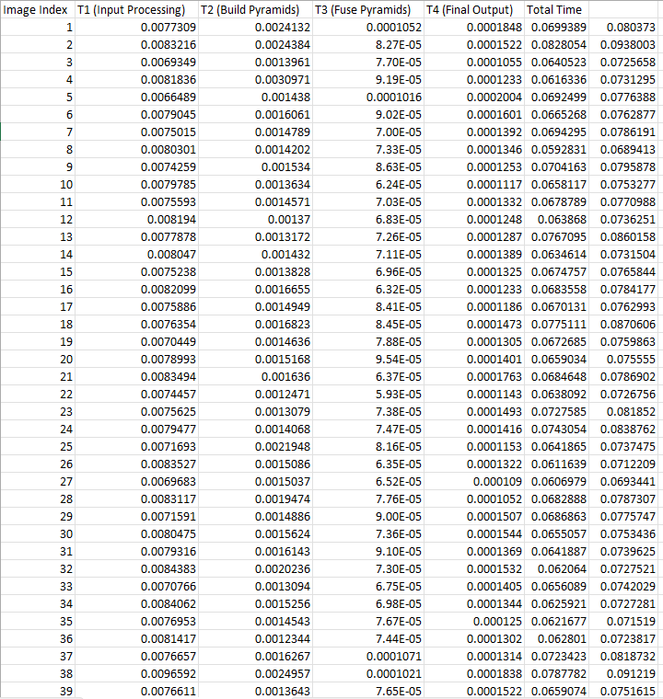

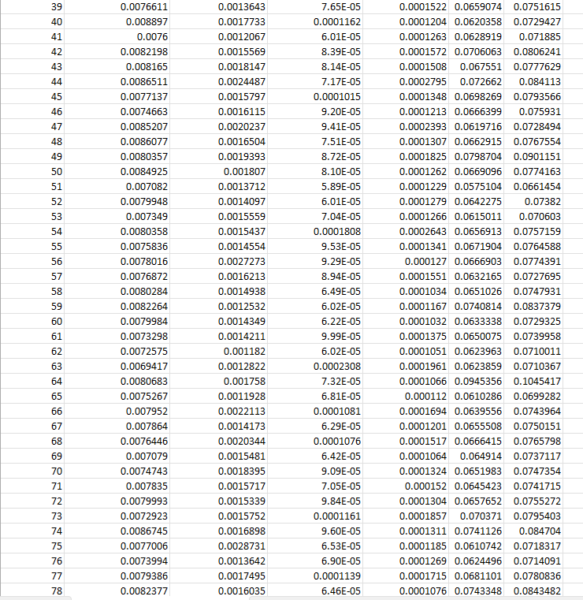

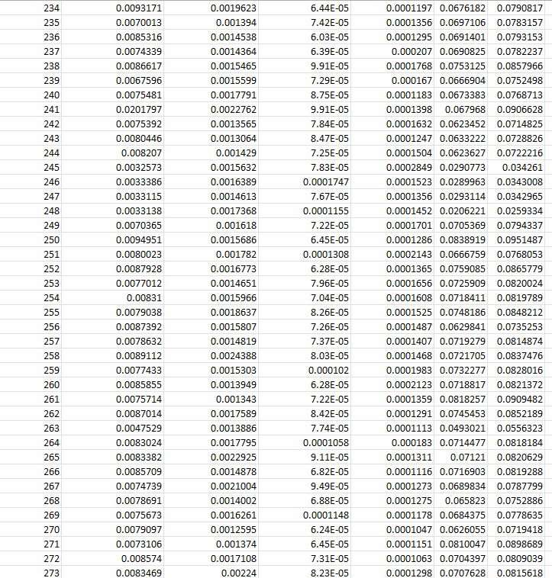

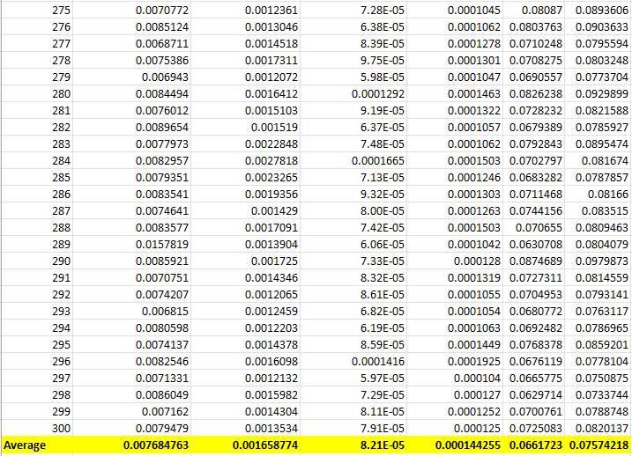

Fusion Time Metrics YcrCb (CPU)

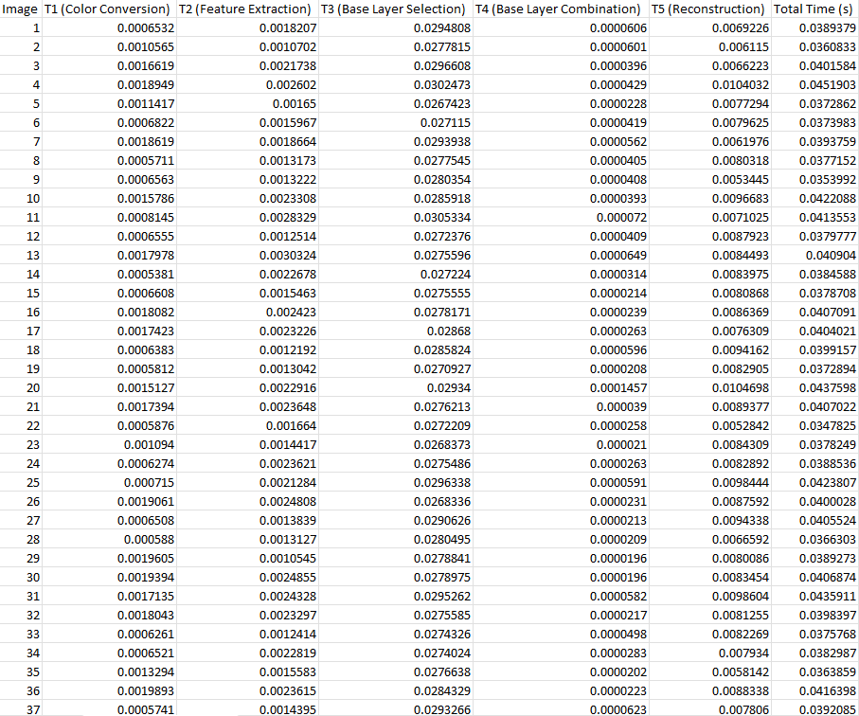

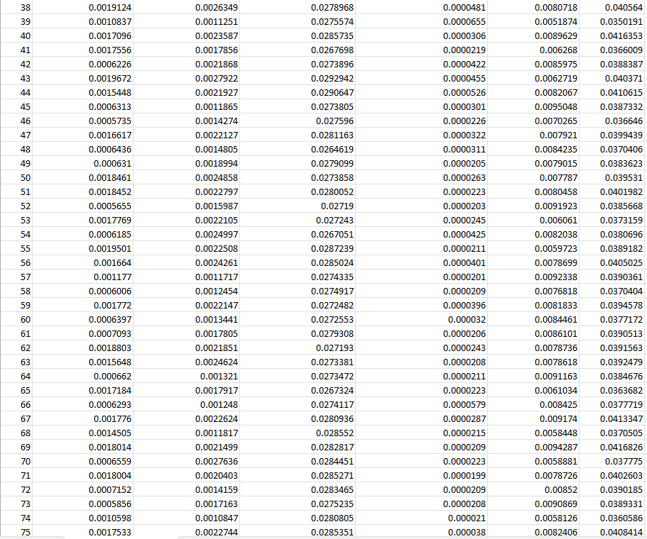

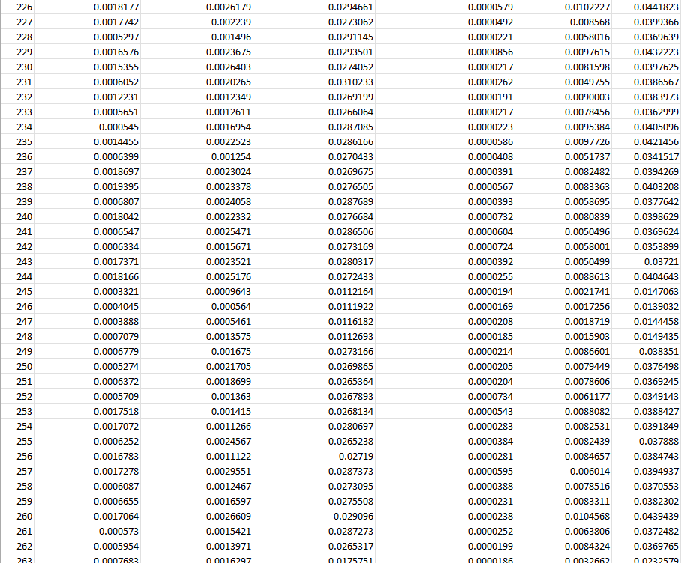

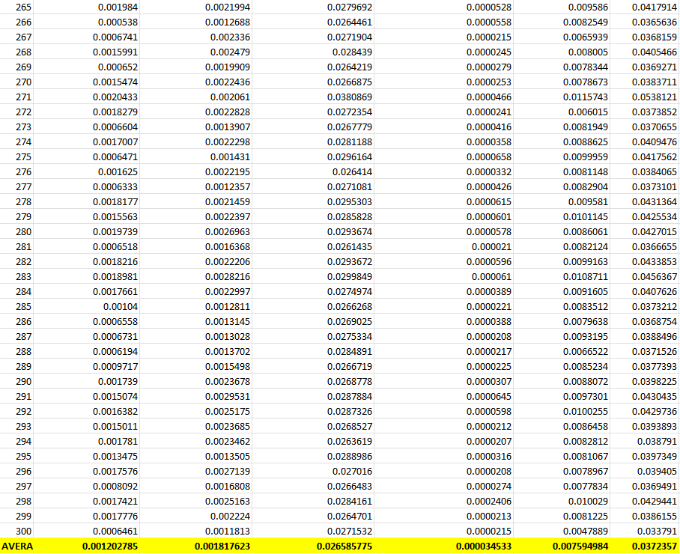

## **Performance Metrics For GPU and CPU**

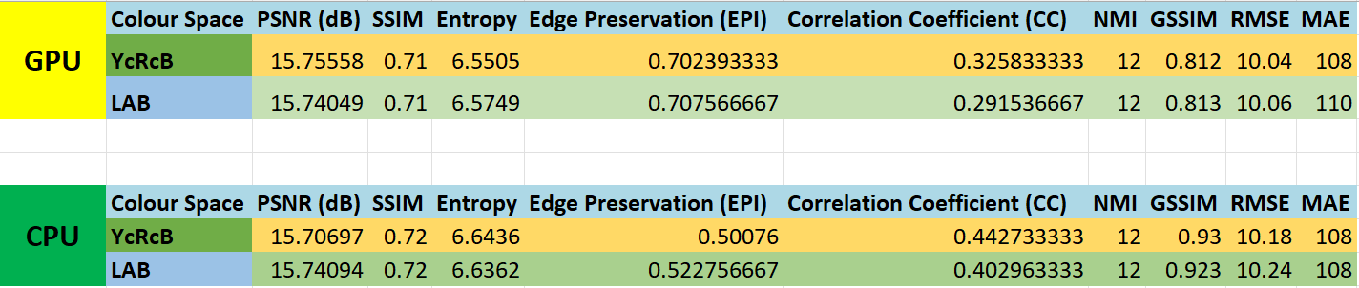

## **Computational Efficiency:**

**Existing Methods**: Many conventional methods, such as PCA and wavelet transform, are computationally intensive, making them less suitable for real-time applications on resource-constrained devices.

**Our Approach**: We optimized the computational efficiency by utilizing parallel processing and hardware acceleration, ensuring that our fusion methods can operate in real-time on devices with limited resources.

## **Real-Time Processing:**

## **Existing Methods**: Methods like IHS and edge detection-based fusion often suffer from high latency, which is problematic for real-time applications.

## **Our Approach**: We designed low-latency algorithms with efficient data handling and streamlined processing steps, achieving real-time performance without compromising image quality.

# **Chapter 7: Conclusion**

## In our project, we explored various color spaces such as YCbCr, LAB, and LCH and performed fusion using the Laplacian Pyramid (LP) fusion method to combine visible and infrared images. We conducted fusion experiments across different color spaces and tabulated the processing time for image fusion using both CUDA and CPU implementations. Additionally, we evaluated performance metrics, including PSNR, SSIM, and entropy, and displayed the average values for each color space. Detailed measurements of computational time were conducted to assess the performance of the fusion algorithms. Strategies to optimize and improve computational efficiency were investigated to ensure the methods meet real-time processing requirements. This included fine-tuning algorithm parameters and exploring hardware acceleration techniques to enhance processing speed and overall system performance. These modifications have improved the quality and efficiency of the fused images, making them more suitable for real-time applications in areas like surveillance, medical imaging, and remote sensing.

# **Chapter 8: Future Work**

## In future work, the implementation of the modified image fusion methods on the NVIDIA Jetson Nano platform will be explored to leverage its computational capabilities for real-time applications.

# **References**

## 4[A Colour-Focused Visible and Infrared Image Fusion Framework for Aiding Human Perception](https://ieeexplore.ieee.org/abstract/document/10677151/) [[N Eswarappa](https://scholar.google.com/citations?user=QV5agwIAAAAJ&hl=en&oi=sra), [S Waldekar](https://scholar.google.com/citations?user=DE0xFUIAAAAJ&hl=en&oi=sra), KM Jeevan, BK Vivek, K George] [12-14 July 2024], 2024 IEEE International Conference on Electronics, Computing

## Infrared and visible image fusion based on domain transform filtering and sparse representation, Xilai Li, Haishu Tan, Fuqiang Zhou, Gao Wang,Xiaosong Li, June 2023, Infrared Physics & Technology, Volume 131, 104701

## [MS-SVD] Image Fusion technique using Multi-resolution singular Value decomposition, VPS Naideu, 2011

## [LP] The Laplacian Pyramid as a Compact Image Code, Burt, 1983

## [MST-LP] Infrared and visible image fusion based on target-enhanced multiscale transform decomposition, 2019